United Christian Women’s Ministries
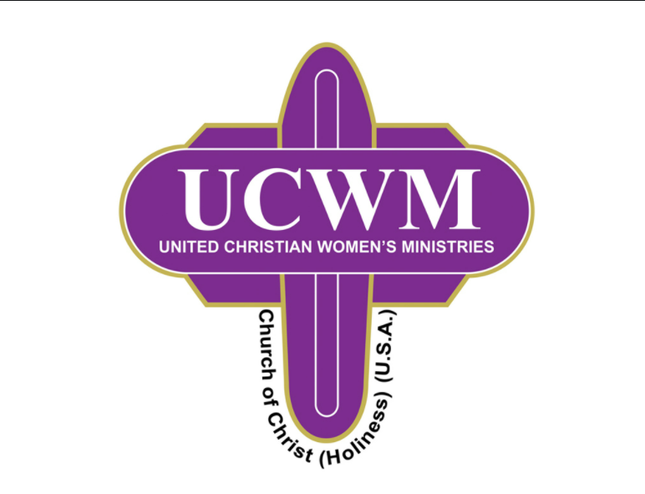

Woman of the Year

PURPOSE
The purpose of this award is to encourage ladies of the UCWM to support all phases of this organization as they strive to make a difference in their homes, churches and communities.

OBJECTIVE
The objective is to identify and recognize women of the UCWM who have accepted the Great Commission given to each Christian in Matthew 28:19-20 and strive to bring about a change in the lives of others.

GUIDELINES
NOTE: Only one candidate at each level (Local, District and Diocese) will be selected and celebrated.

- Each Local UCWM will select a Woman of the Year candidate based on the criteria attached. The candidate will complete the resume, which includes: a) a personal profile, b) references and c) clear photograph for reproduction. (See attached Resume Guidelines)

- The Local UCWM Woman of the Year Committee will use the attached Summary Sheet to award points for resumes completed by each candidate. If there is a tie, the local UCWM President will break the tie however she deems appropriate. The final candidate’s resume will be submitted to the District UCWM President. Information should be reviewed for accuracy and completeness before submitting to the District UCWM President.

- The District UCWM Woman of the Year Committee will review resumes of candidates submitted for consideration. Using the Woman of the Year Summary Sheet, the Committee will award points for resumes completed by candidates. If there is a tie, the District UCWM President will break the tie however she deems appropriate. The final candidate’s resume will be submitted to the Diocese UCWM President.

- The Woman of the Year will be selected at the Diocese level by the UCWM Woman of the Year Committee, consisting of representatives from each district. The Diocese UCWM Woman of the Year will be chosen based on the total number of points awarded using the values on the Woman of the Year Summary Sheet. If there is a tie, the Diocese UCWM President will break the tie however she deems appropriate.

- The diocese Woman of the Year’s resume (personal profile, references, clear photograph for reproducing) must be forwarded to the National UCWM Woman of the Year Facilitator via email by the deadline given. Nationally, this is not a competition but an opportunity to recognize and celebrate each diocese Woman of the Year.
United Christian Women’s Ministries

Woman of the Year Resume Guidelines

CRITERIA
- The applicant must be a born-again believer who demonstrates her salvation in both word and deed.

- The applicant must be an active member on all levels of the UCWM (local, district and diocese).

- The applicant must be supportive of other ministries and activities in their local church (i.e., Sunday School, Bible Study, Prayer Meeting, etc.).

PERSONAL PROFILE (To be attached separately using the following format):

 | Short Biography | 20 points
 | Church Activities (local, district and diocese levels) | 15 points
 | Community Service | 15 points
 | Spiritual/Personal Accomplishments and Goals | 25 points
 | Character References (2 requested—please attach) | 20 points
 | Photograph (clear photo for reproduction) | 5 points

The personal profile presented to the National UCWM Woman of the Year Facilitator must contain the following signatures (signature page attached):

- Local UCWM President
- District UCWM President
- Diocese UCWM President

NOTE:
The criteria for judging and rating candidates should reflect the candidate’s commitment, desire and achievement(s) instead of the number of positions held or their years of service.

United Christian Women’s Ministries

Woman of the Year Summary Sheet

Candidate’s Name: ________________________________________________________

 |  | Possible Points | Points Awarded
 | Short Biography | 20 | _______
 | Church Activities (local, district and diocese levels) | 15 | _______
 | Community Service | 15 | _______
 | Spiritual/Personal Accomplishments and Goals | 25 | _______
 | Character References (2 requested—please attach) | 20 | _______
 | Photograph (clear photo for reproduction) | 5 | _______

Comments: ______________________________________________________________
________________________________________________________________________
__ __ __ __ __ __ __ __ __ __ __ __ __ __ __ __ __ __ __ __ __ __

Candidate’s Name: ________________________________________________________

 |  | Possible Points | Points Awarded
 | Short Biography | 20 | _______
 | Church Activities (local, district and diocese levels) | 15 | _______
 | Community Service | 15 | _______
 | Spiritual/Personal Accomplishments and Goals | 25 | _______
 | Character References (2 requested—please attach) | 20 | _______
 | Photograph (clear photo for reproduction) | 5 | _______

Comments: ______________________________________________________________
________________________________________________________________________
United Christian Women’s Ministries

Woman of the Year

Signature Page

Local UCWM President | __________________________________________  Signature  Email Address: ________________________________
District UCWM President | __________________________________________  Signature  Email Address: ________________________________
Diocese UCWM President | __________________________________________  Signature  Email Address: ________________________________

